@Required.
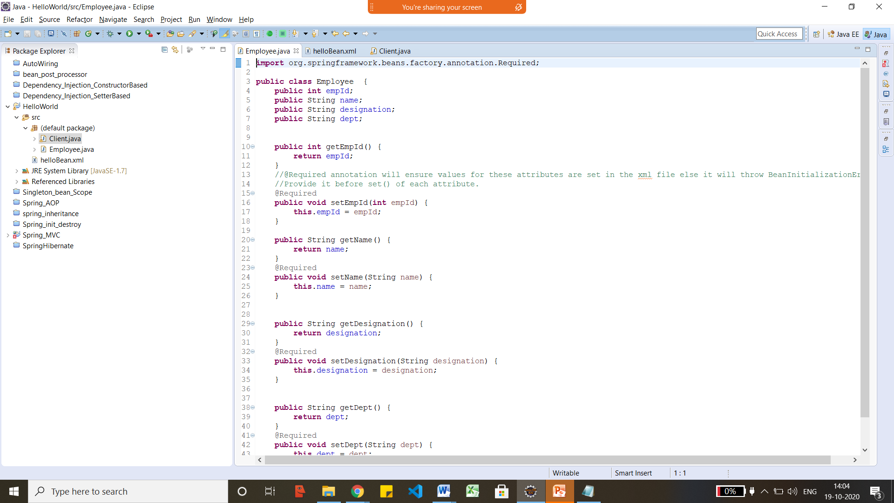
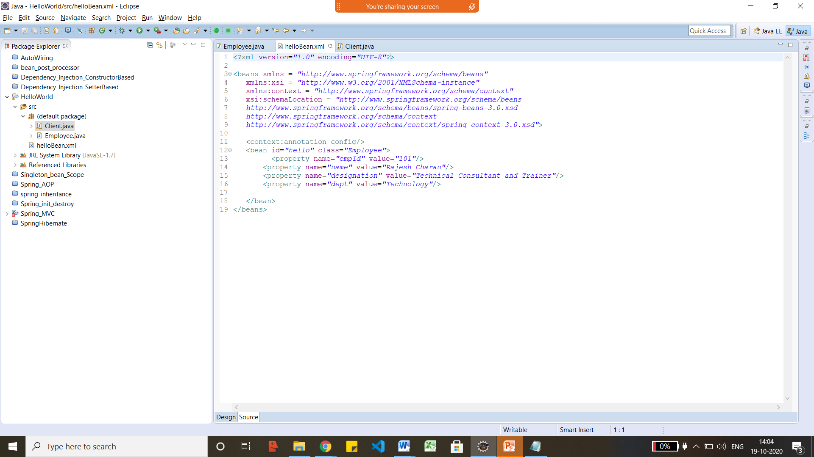
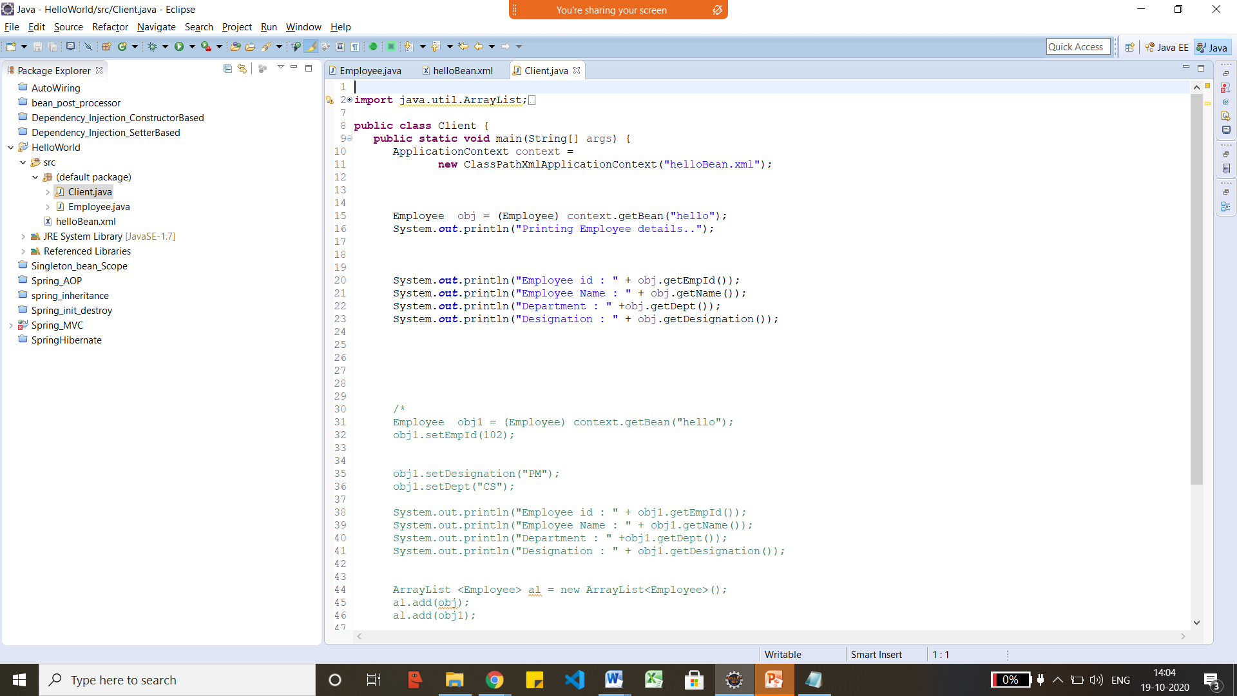

Dependency Injection Setter based.
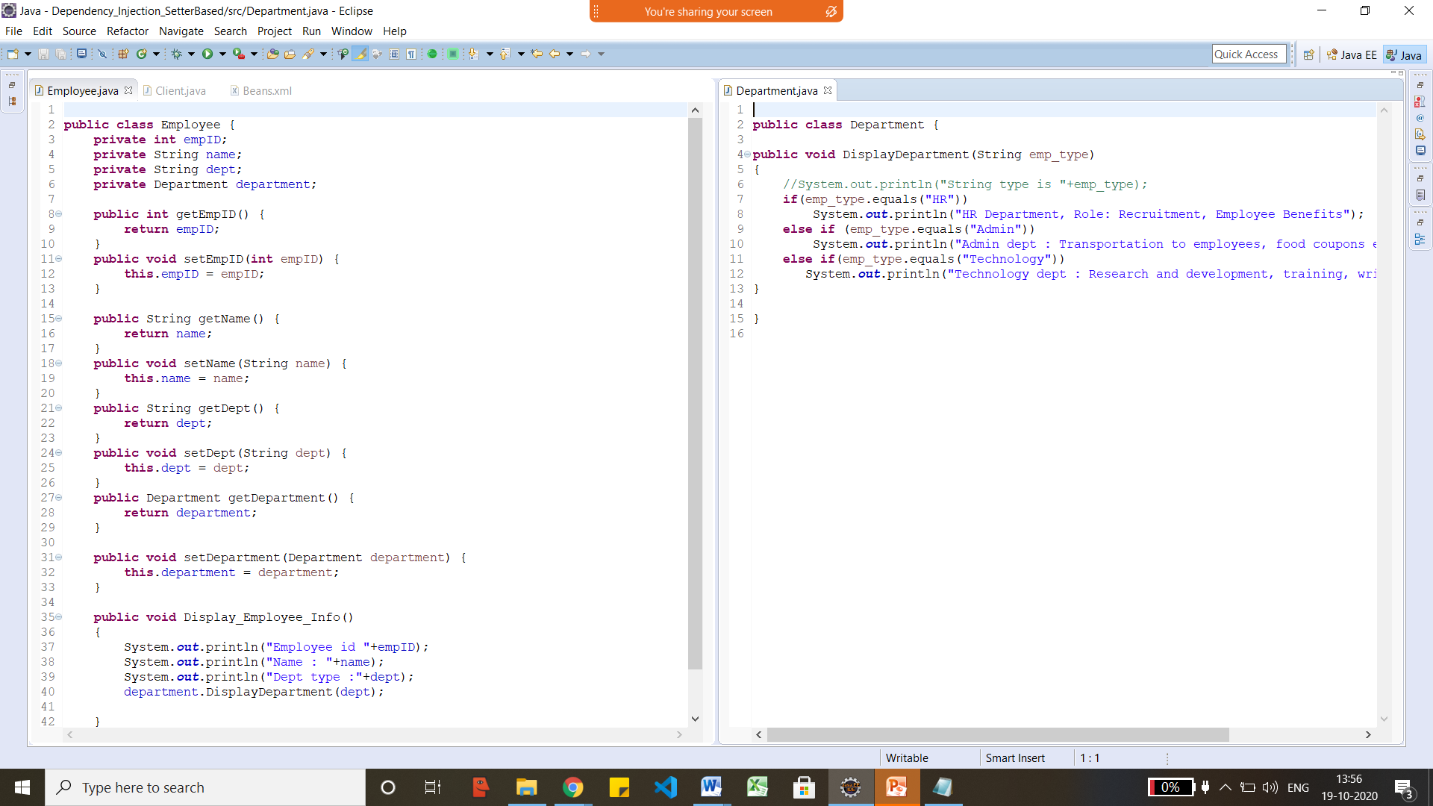
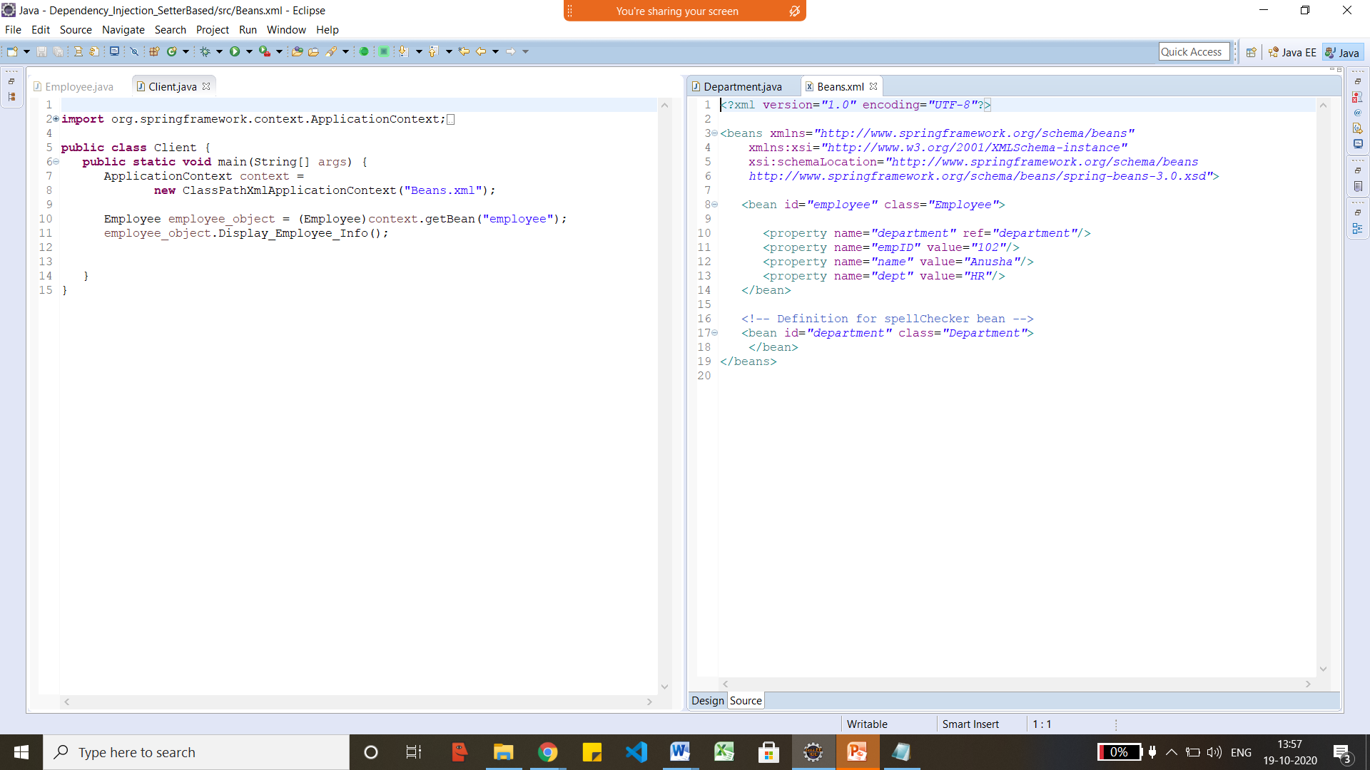

Dependency Injection Constructor based
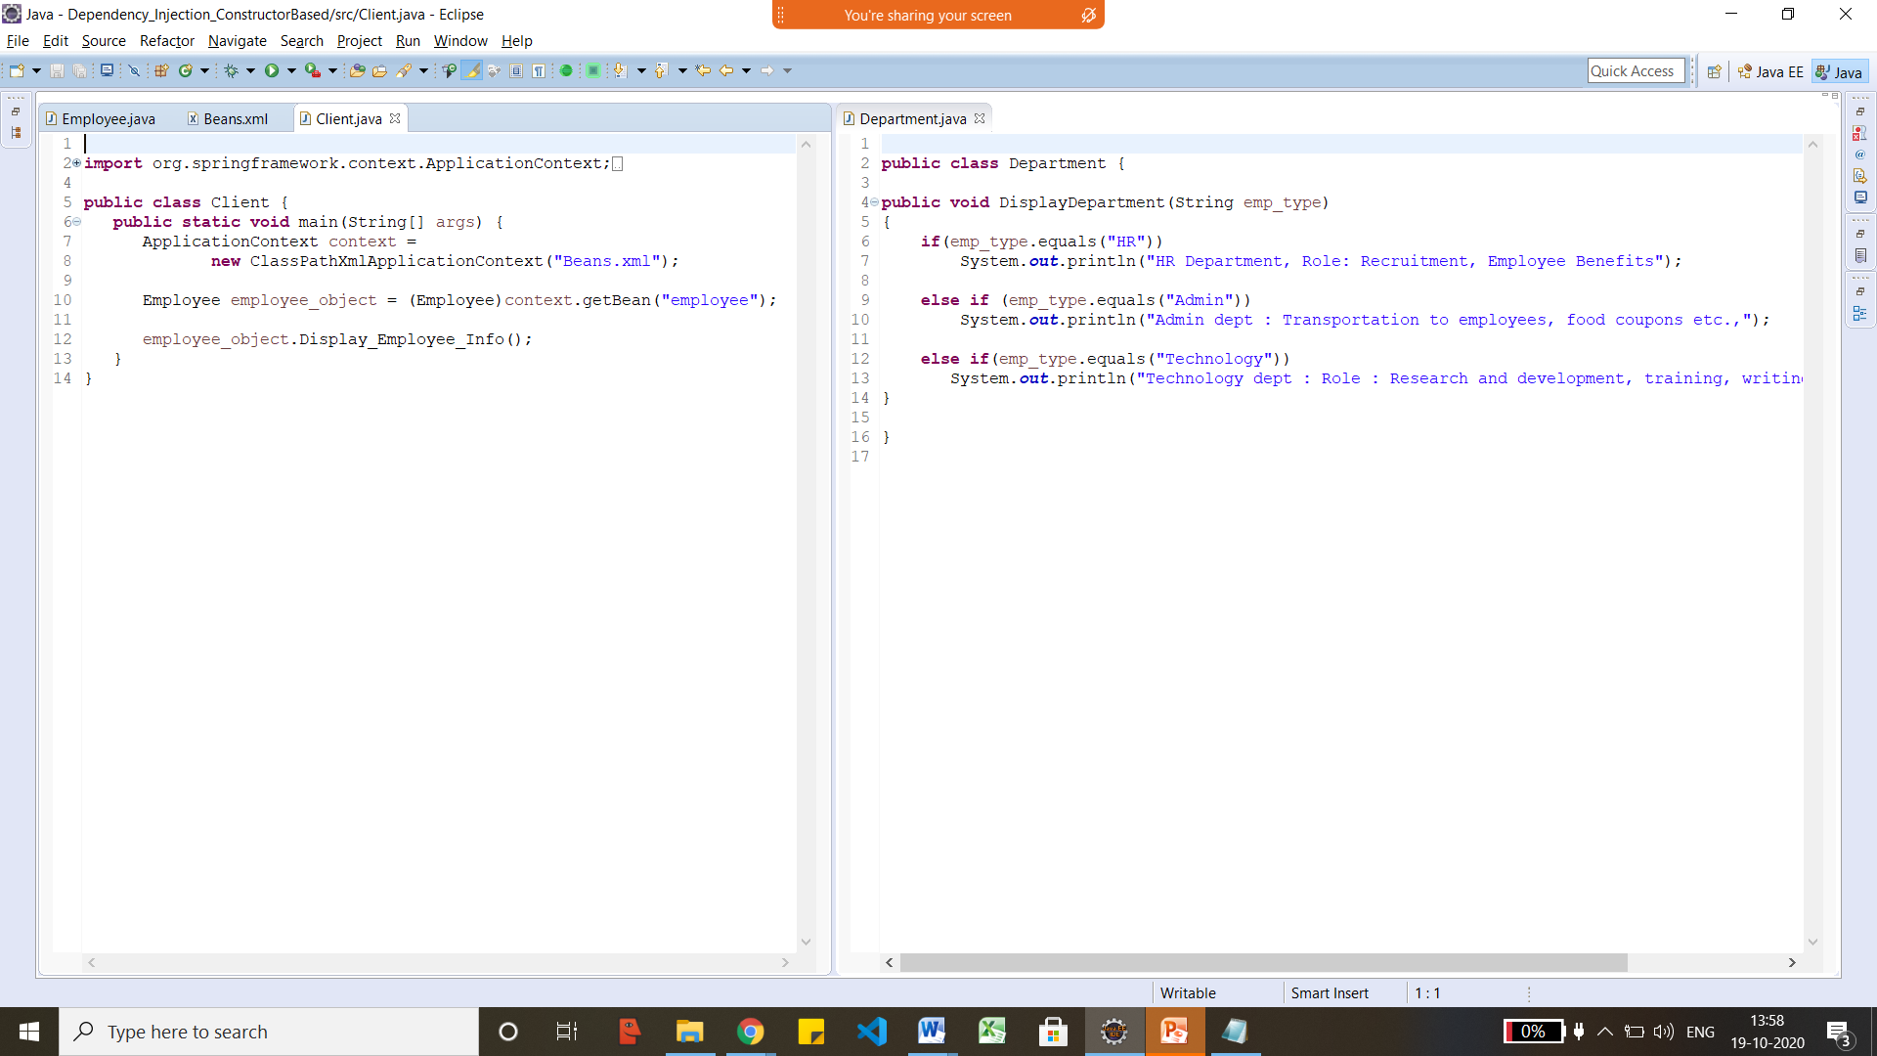

<?xml version="1.0" encoding="UTF-8"?>

<beans xmlns="http://www.springframework.org/schema/beans"
xmlns:xsi="http://www.w3.org/2001/XMLSchema-instance"
xsi:schemaLocation="http://www.springframework.org/schema/beans
http://www.springframework.org/schema/beans/spring-beans-3.0.xsd">

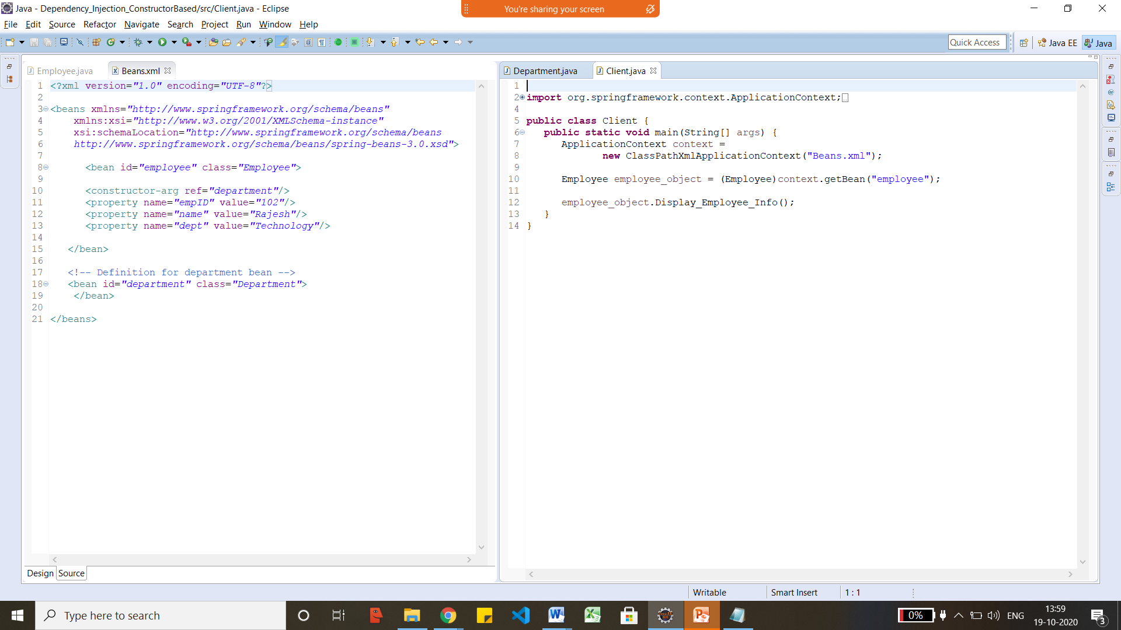

Dependency Injection - @Autowired
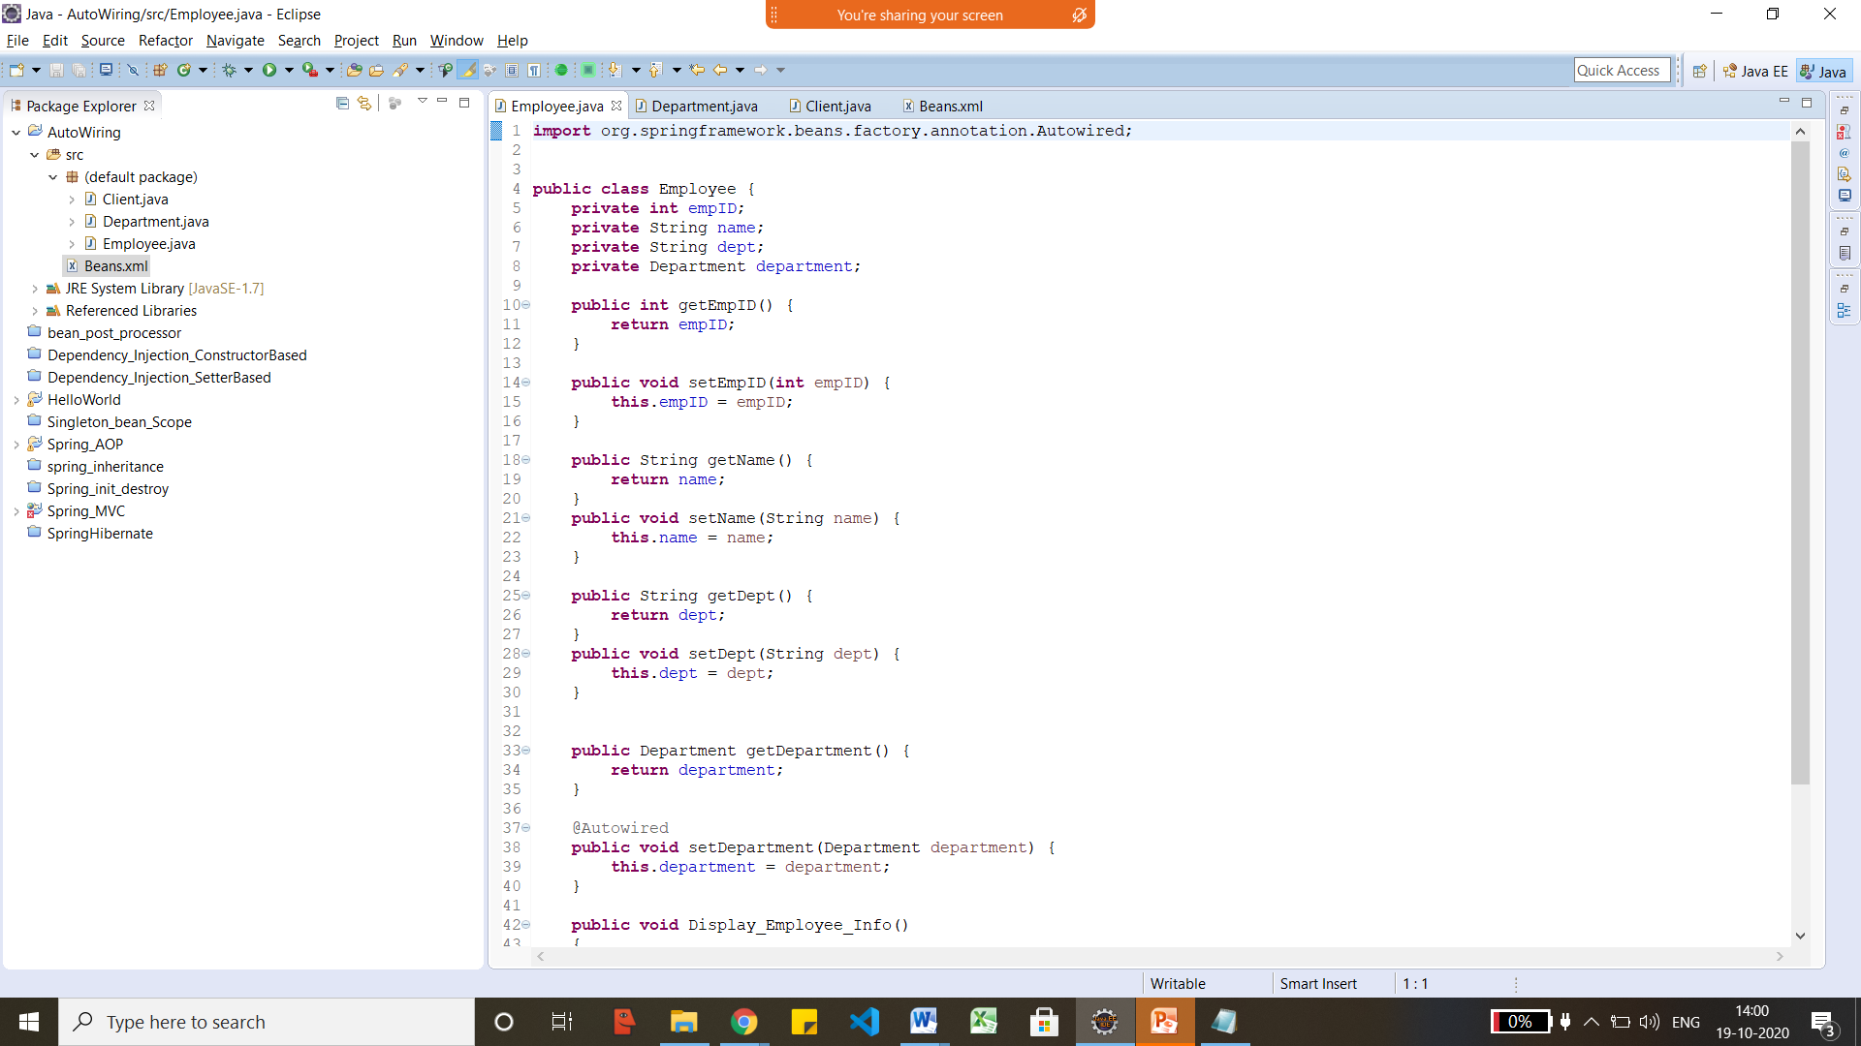
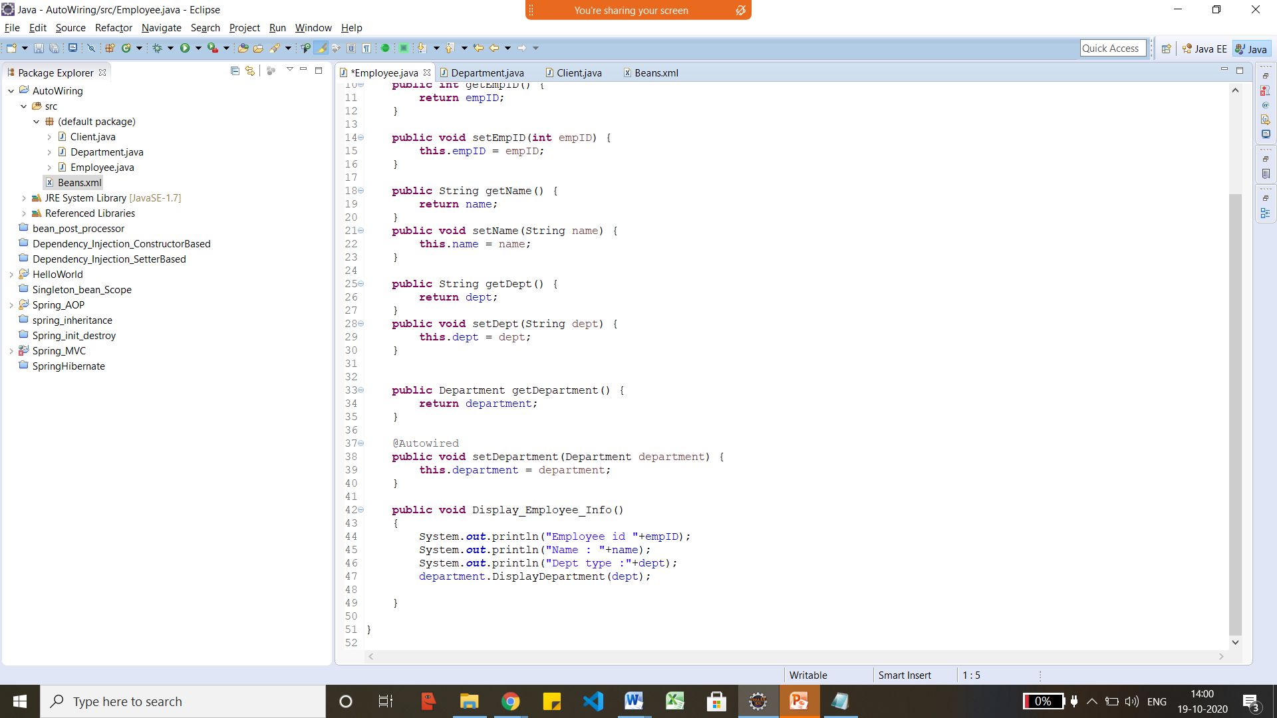
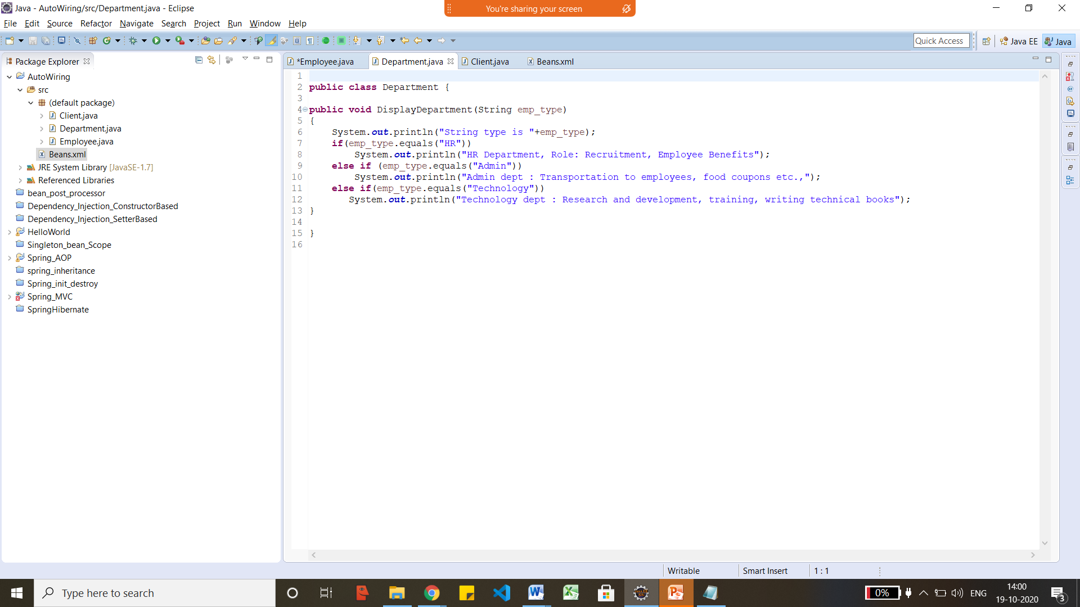
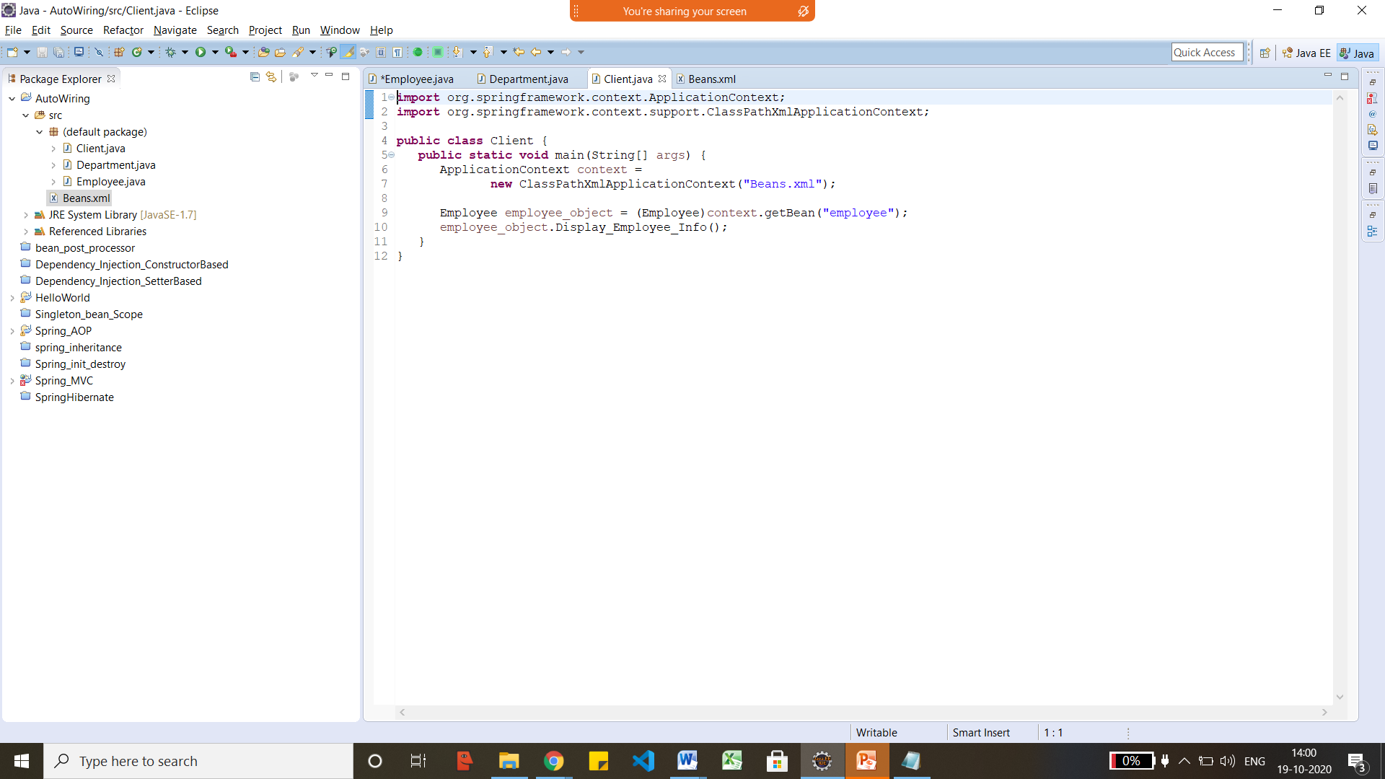

<?xml version="1.0" encoding="UTF-8"?>

<beans xmlns="http://www.springframework.org/schema/beans"
xmlns:xsi="http://www.w3.org/2001/XMLSchema-instance"
xmlns:context="http://www.springframework.org/schema/context"
xsi:schemaLocation="http://www.springframework.org/schema/beans
http://www.springframework.org/schema/beans/spring-beans-3.0.xsd
http://www.springframework.org/schema/context
http://www.springframework.org/schema/context/spring-context-3.0.xsd">

<context:annotation-config/>

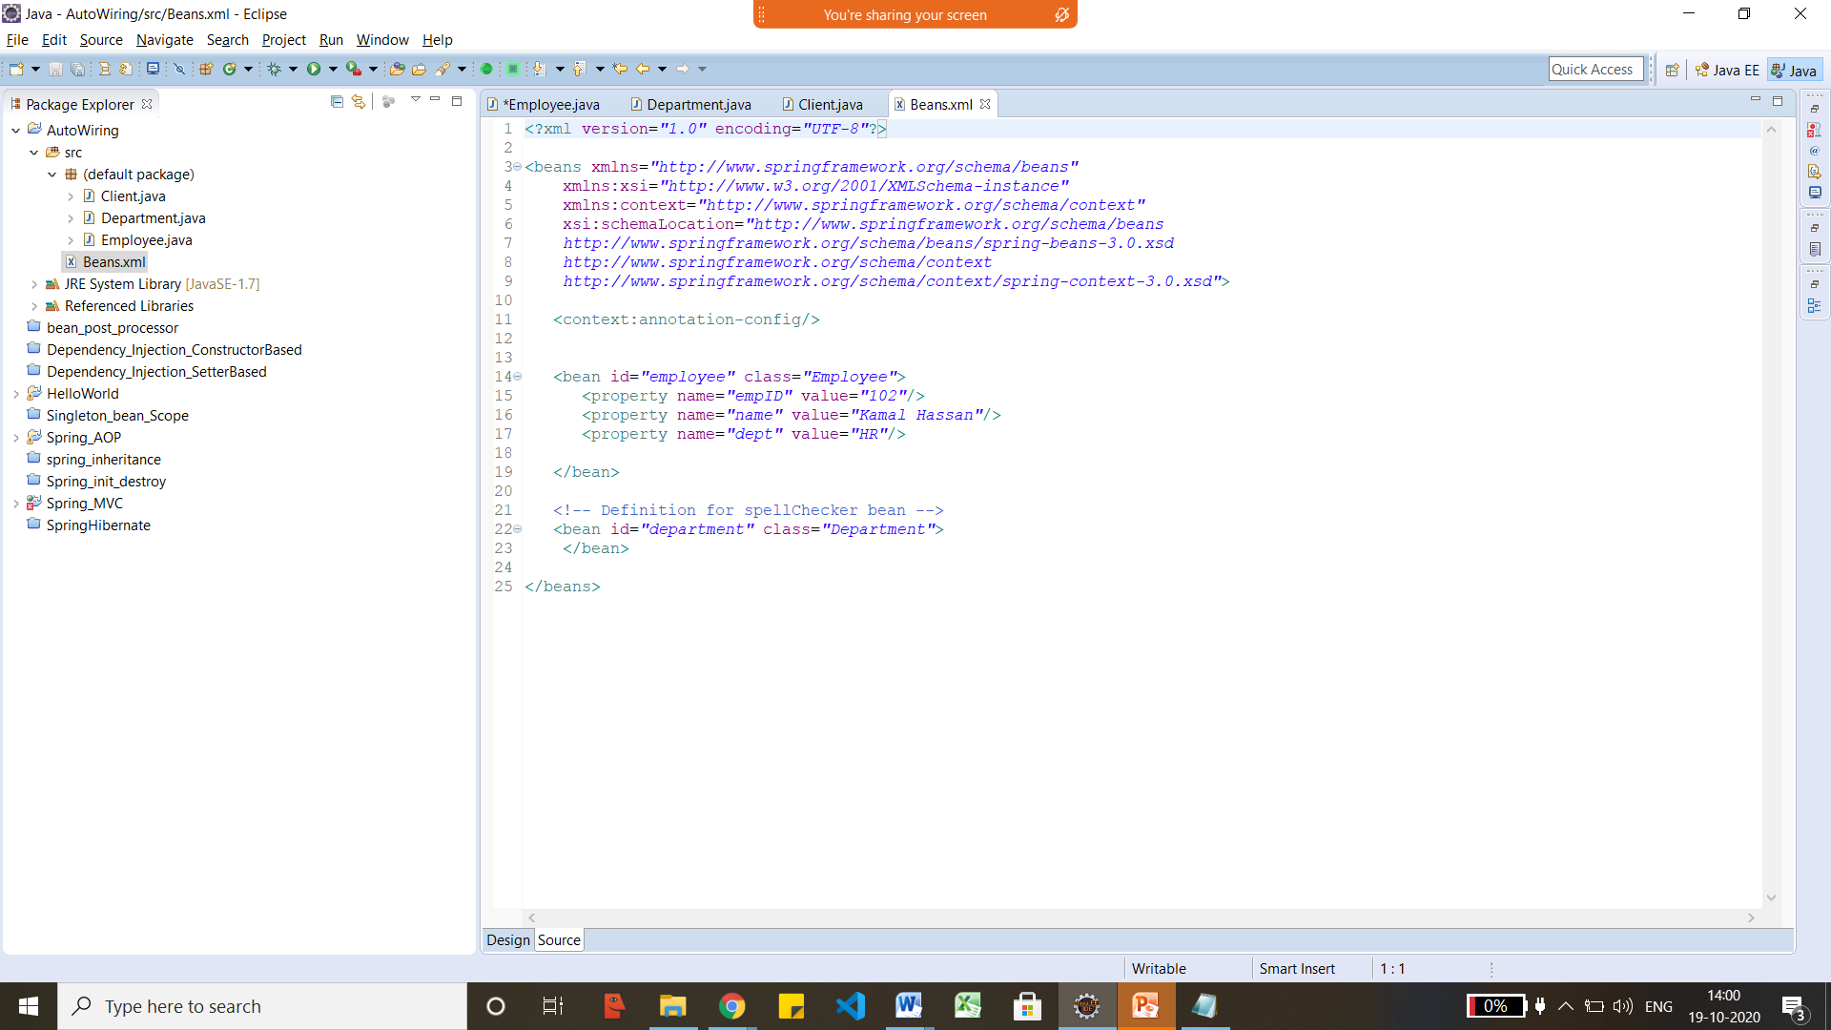

AOP
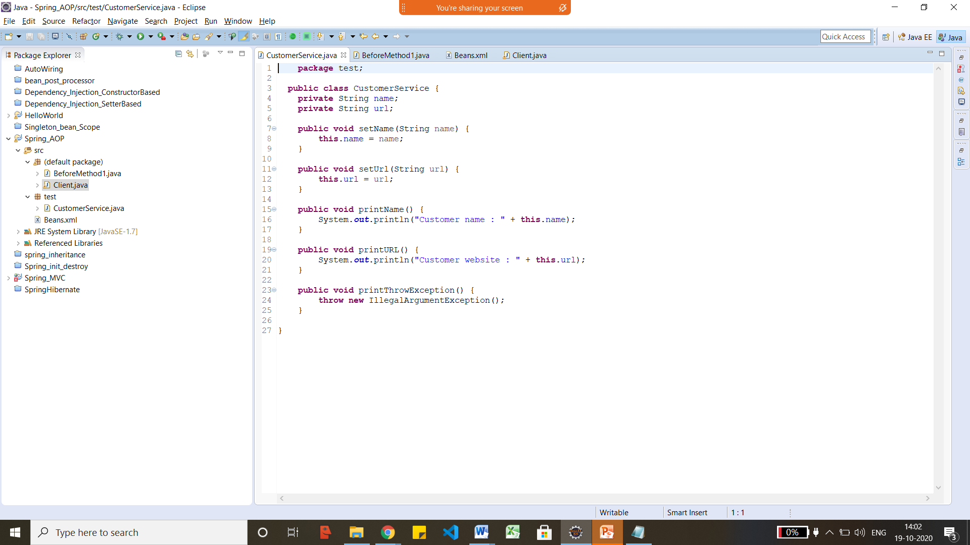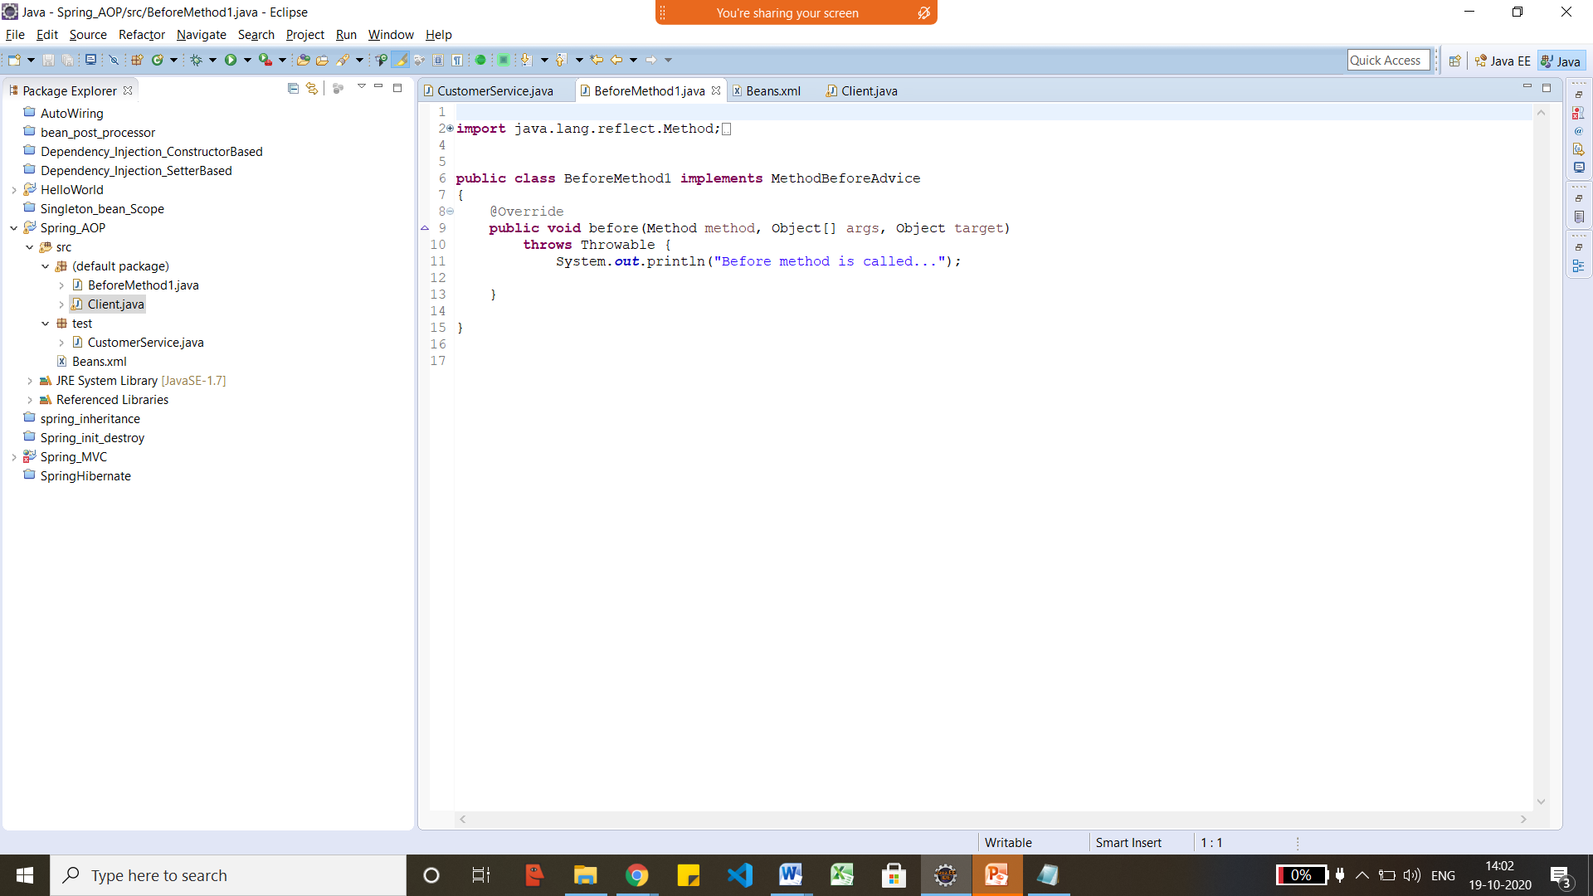

<?xml version="1.0" encoding="UTF-8"?>
<beans
xmlns="http://www.springframework.org/schema/beans"
xmlns:xsi="http://www.w3.org/2001/XMLSchema-instance"
xmlns:p="http://www.springframework.org/schema/p"
xsi:schemaLocation="http://www.springframework.org/schema/beans
http://www.springframework.org/schema/beans/spring-beans-3.0.xsd">
